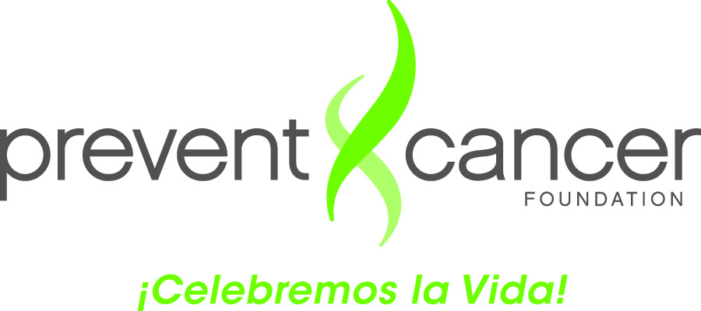

Guide for Completing the Campeonas Log

Purpose of the Contact Log: To assist Campeonas with collecting and tracking information
about their conversations with the women they contacted

The Log has two (2) sections:

Section I: Provides information about you and the place where you were trained:

- Campeona’s name: First and last name

- City: Name of the city where you live

- State: Name of the state where you live

- Training Location and name of the organization: City and State where you were trained and name of the organization providing the training

Section II: Provides information from the women you talked to:

- Date of the conversation: Month, day and the year (e.g., 01/01/12)

- Name of the woman you talked to: Only first name is required

- Age: For example, 40 years old

- Country of Origin: Country where the woman you talked to was born (e.g., El Salvador)

- Relationship: Your relationship with the other person (e.g., mother, sister, comadre, daughter, grandmother, friend, church member, or other)

- Materials from the folder: Novela and the list programs with free mammography. (Indicate with a check mark () if they were provided to the woman when you spoke to her.)

- Willing to have a mammogram?: Mark Yes or No

- Comments: Brief comments regarding your conversation if you think are needed

