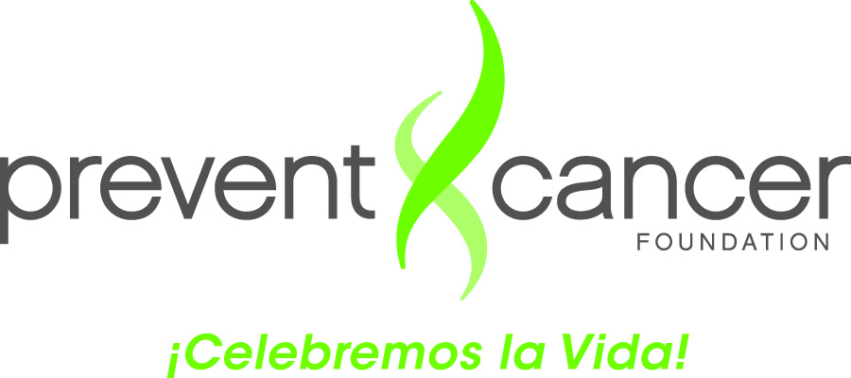

What You Need to Remember from
The Campeonas Training

5 Easy Steps

- Catch up with your friend or family member.
- Tell her about your experience having a mammogram.
- Read the novela “A Timely Encounter” (“Un Encuentro Oportuno”) with her, and give her a copy to keep.
- Give her a copy of the list of programs with free mammograms, and encourage her to make an appointment.
- Record your conversation in the Campeonas Log.

The 3 Es

- Escuchar: TO LISTEN to what your friend or relative says and how she says it

- Entender: TO UNDERSTAND the meaning of her response and her situation

- Empoderar: TO EMPOWER by motivating her to action because she believes she can do it

Other Tips
- Be yourself: Warm, natural, respectful, and sensitive.

- Let the conversation flow naturally, without pressure.

- The purpose is to encourage the woman to get screened for breast cancer. Don’t feel pressure to give medical information. Refer your friend or family member to your contact at your clinic.

- In case of any problems or questions, call your contact at your clinic.

